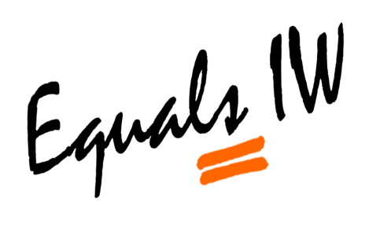
Island Carnivals 2019

The Trustees of Equals IW are delighted with all the amazing contributions by all the 2019 Mardi Gras Team Members. As not to waste the many hours put into making the costumes, creation of Lizard and Mini Forest. The Trustees would like to encourage the team members to enter the Mardi Gras theme into the island Illuminated Carnivals of 2019. With the aim to further promote Equals IW and support other community events whilst developing friendships of group members and encouraging others to join Equals IW.
Please complete the below form by placing a tick in the YES or NO Column by Sunday 7th July 2019. Then either email your confirmation to mark@mcenhancement.com OR post Mark Cox, Penthouse 5, 29 Bedworth House, Bedworth Place, Ryde, Isle of Wight, PO33 2RF.
Everyone welcome including children of Team Members of Equals IW!

Name(S) ________________________________________

Carnival Evening | Date | YES | NO
Shanklin Illuminated | 10/08/2019
Ventnor Illuminated | 17/08/2019
Newport Illuminated | 22/08/2019
Cowes Illuminated | 24/08/2019
Sandown Illuminated | 28/08/2019
Ryde Illuminated | 31/08/2019

